Lab 19

Create a Java application to calculate monthly mortgage repayments. When the application is run and the user enters correct data we see the following screen:

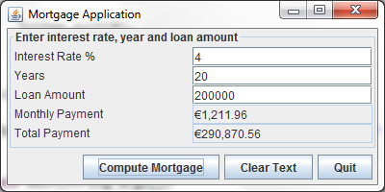

The user inputs the interest rate, number of years and total loan amount and presses Compute Mortgage. The monthly payment and total payment are then displayed. Note that these text boxes are disabled. Use the method setEditable().

The following code is a constructor for a Mortgage class and two methods that should be used in the application and when called, calculate the mortgage. Each time the Compute Mortgage button is pressed an ID number is assigned to the calculation.

// Constructor
public Mortgage(int Id, double i, int y, double l)
{
ID = Id;
interest = i/1200.0;
year = y;
loan = l;
}
// Find monthly pay
public double monthlyPay()
{
return loan*interest/(1-(Math.pow(1/(1+interest),year*12)));
}
// Find total pay
public double totalPay()
{
return monthlyPay()*year*12;
}
Error Handling
- If the user enters invalid data or no data then you need to catch the NumberFormatException and display an appropriate message to the user.
- Use the JOptionPane.showMessageDialog()method to display a message to the user like the one shown below.

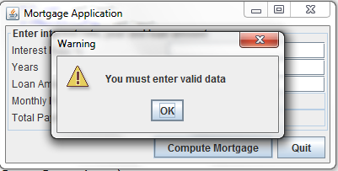

Centering the Window
To make the application window (JFrame) appear in the centre of your screen you can use the following method instead of setLocation().

setLocationRelativeTo(null);

Formatting Output
The monthly payments and total amount should be formatted as shown in the output screen.

Border
Note the border that is placed around the top panel. This is done by using the following method:

p1.setBorder(new TitledBorder("Enter interest rate, year and loan amount"));

You will need to import the following package in order to use this method:

import javax.swing.border.*;

Test Class
Create a separate test class to run the application

